### Semester One Examination, 2018



### Question/Answer booklet

# Year 11

# MATHEMATICS METHODS

## Section Two:

## Calculator Allowed

**Booklet 2 of 3**

Student name

|  |  |  |  |  |  |
| --- | --- | --- | --- | --- | --- |
| **IFB** | **DD** | **VMU** | **SWA** | **MS** | **AGC** |

**Circle your teacher’s Initials:**

## Time allowed for this section

Reading time before commencing work: ten minutes

Working time: one hundred minutes

## Materials required/recommended for this section

***To be provided by the supervisor***

Two Question/Answer booklets – complete both.

Formula sheet (retained from Section One)

***To be provided by the candidate***

Standard items: pens (blue/black preferred), pencils (including coloured), sharpener,  
correction fluid/tape, eraser, ruler, highlighters

Special items: drawing instruments, templates, notes on two unfolded sheets of A4 paper, and up to three calculators approved for use in this examination

## Important note to candidates

No other items may be taken into the examination room. It is **your** responsibility to ensure that you do not have any unauthorised material. If you have any unauthorised material with you, hand it to the supervisor **before** reading any further.

## Structure of this paper

|  |  |  |  |  |  |
| --- | --- | --- | --- | --- | --- |
| Section | Number of questions available | Number of questions to be answered | Working  time (minutes) | Marks available | Percentage of examination |
| Section One:  Calculator-free | 9 | 9 | 50 | 67 | 35 |
| Section Two:  Calculator-assumed | 13 | 13 | 100 | 84 | 65 |
|  | | |  | **Total** | 100 |

## Instructions to candidates

1. The rules for the conduct of examinations are detailed in the school handbook. Sitting this examination implies that you agree to abide by these rules.

2. Write your answers in this Question/Answer booklet.

3. You must be careful to confine your response to the specific question asked and to follow any instructions that are specified to a particular question.

4. Supplementary pages for the use of planning/continuing your answer to a question  
have been provided at the end of this Question/Answer booklet. If you use these pages to continue an answer, indicate at the original answer where the answer is continued, i.e. give the page number.

5. Show all your working clearly. Your working should be in sufficient detail to allow your answers to be checked readily and for marks to be awarded for reasoning. Incorrect answers given without supporting reasoning cannot be allocated any marks. For any question or part question worth more than two marks, valid working or justification is required to receive full marks. If you repeat any question, ensure that you cancel the answer you do not wish to have marked.

6. It is recommended that you do not use pencil, except in diagrams.

7. The Formula sheet is not to be handed in with your Question/Answer booklet.

Section Two: Calculator-assumed 65% (84 Marks)

This section has**thirteen (****13)** questions. Answer **all** questions. Write your answers in the spaces provided.

Working time: 100 minutes.

Question 10 (3 marks)

The graphs of $y=2x^{2}+2x+c$, $y=a{\left(x-2\right)}^{2}+1$ and $y=(x+b)(x+3)$ are shown below.

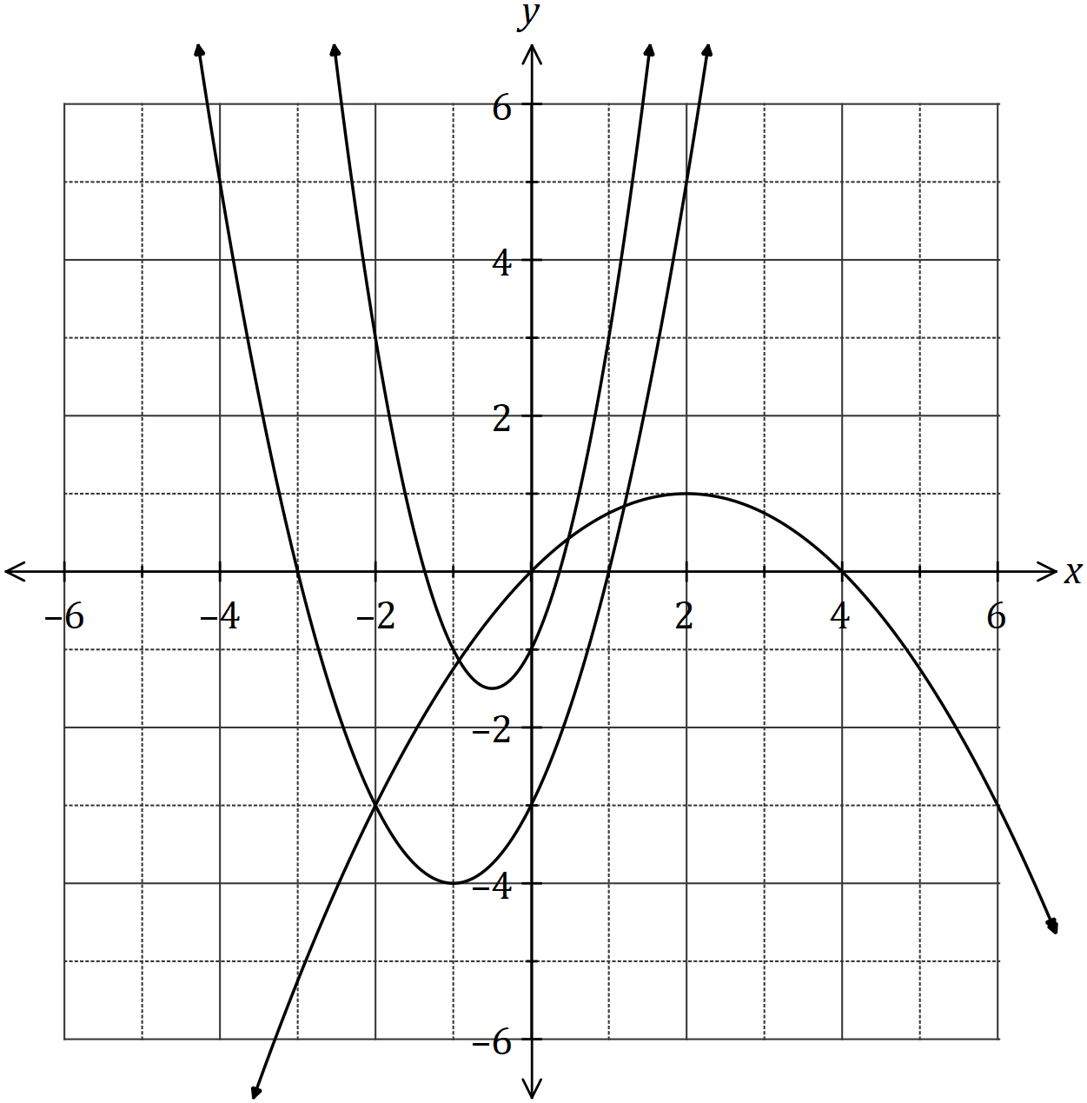

Determine the values of the constants $a, b$ and $c$.

Question 11 (8 marks)

The graph below is .

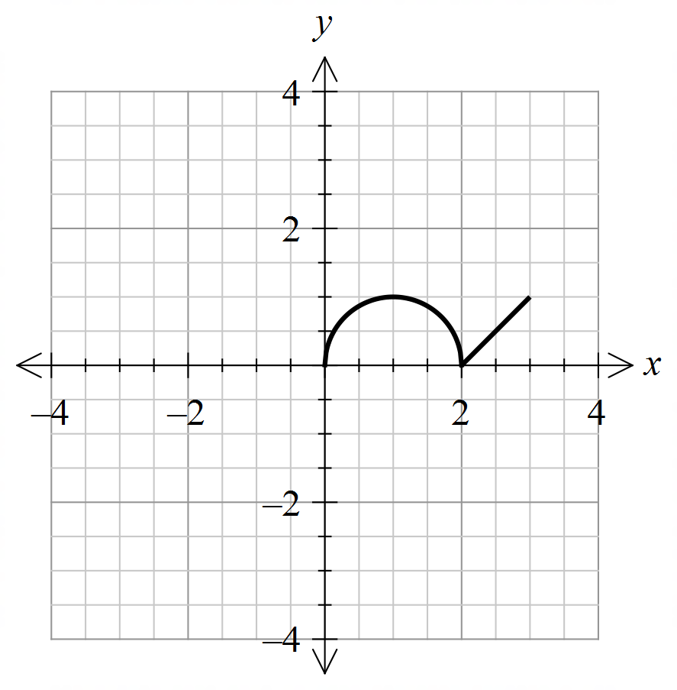

On each of the axes below sketch the required function. (1 mark)

(a) 

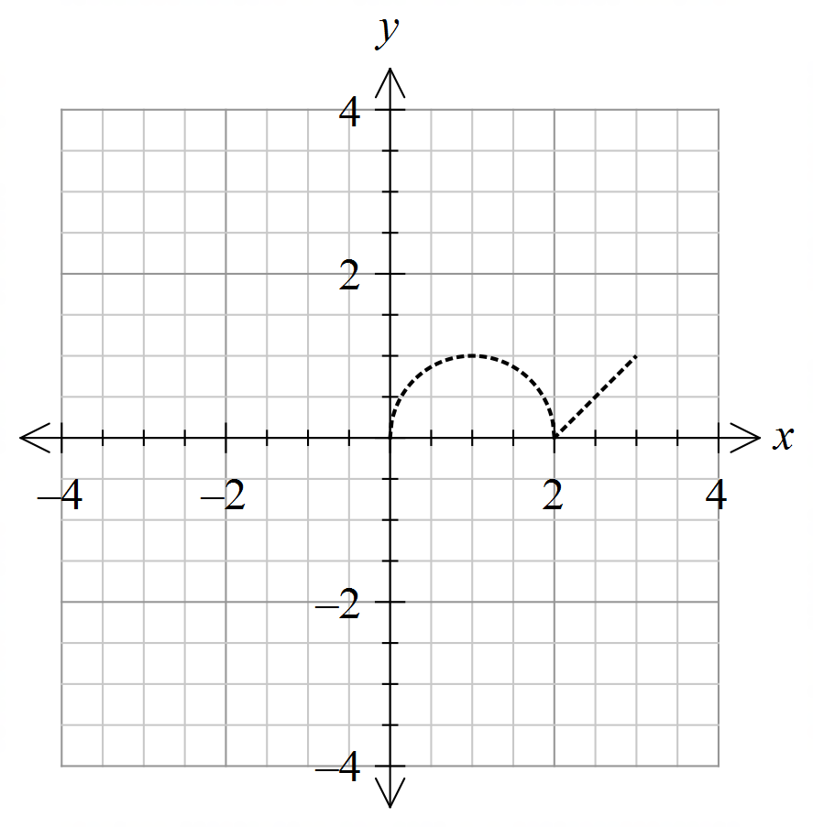

(b)  (2 marks)



(c)  (2 marks)

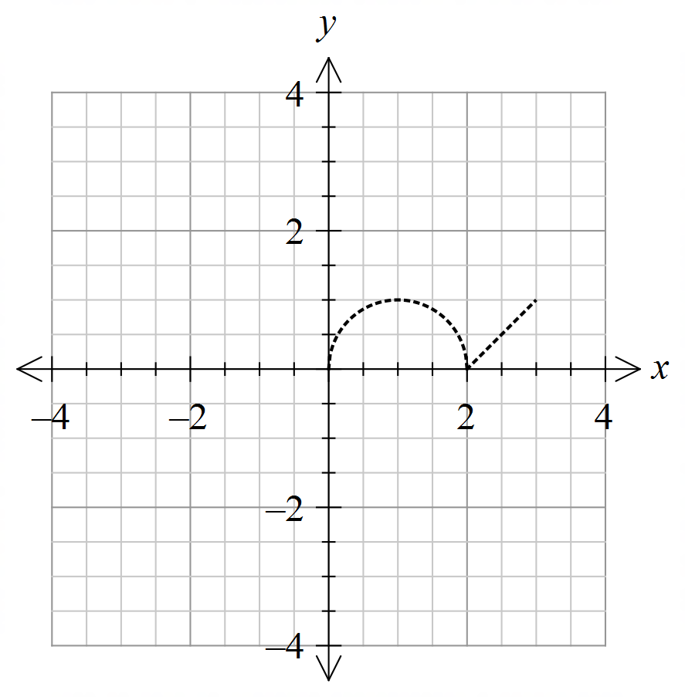

(d) Write the function for this transformation of  (3 marks)

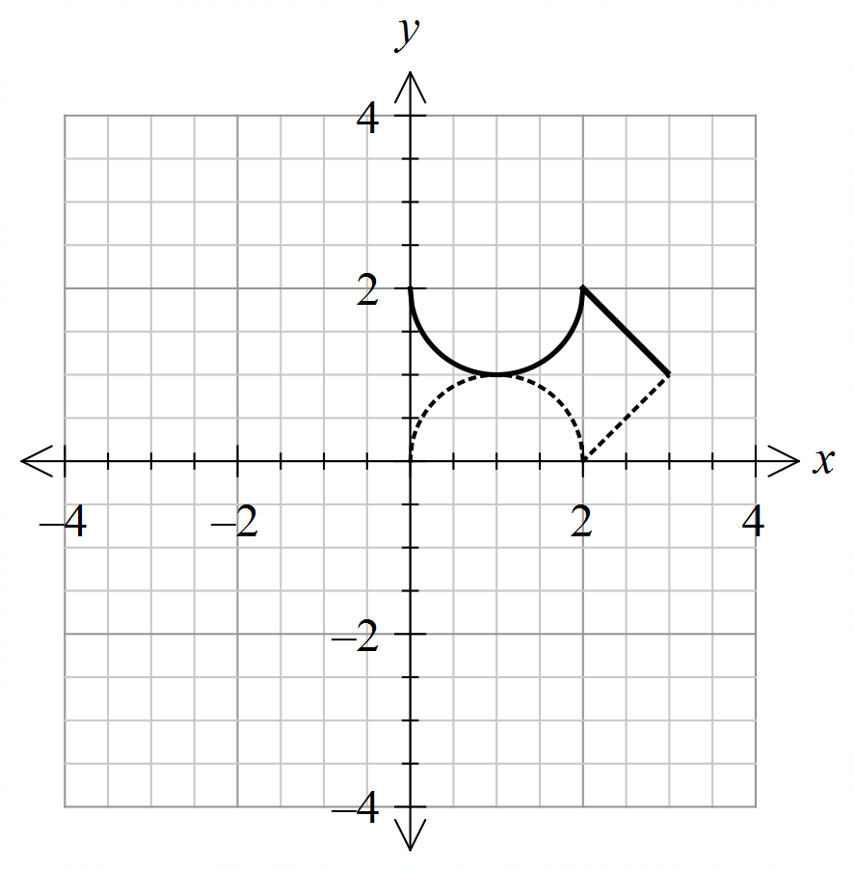

Function: _______________________

Question 12 (6 marks)

A goal post stands vertically on the playing surface of Craig Oval. From point $A$ on Craig Oval, the angle of elevation to the top of the goal post, $T$, is 18º.

From point $B$, also on Craig Oval, but 5.35 metres further from the foot of the goal post than $A$, the angle of elevation to the top of the goal post is 15º.

(a) Draw a diagram to represent this information. (1 mark)

(b) Calculate the height of the goal post. (5 marks)

Question 13 (8 marks)

Let $f\left(x\right)=\begin{matrix}4 \\ \overline{3-x}\end{matrix}$ and $g\left(x\right)=\begin{matrix}1 \\ \overline{x+p}\end{matrix}+q$, where $p$ and $q$ are constants.

The graph of $y=g(x)$ is shown below.

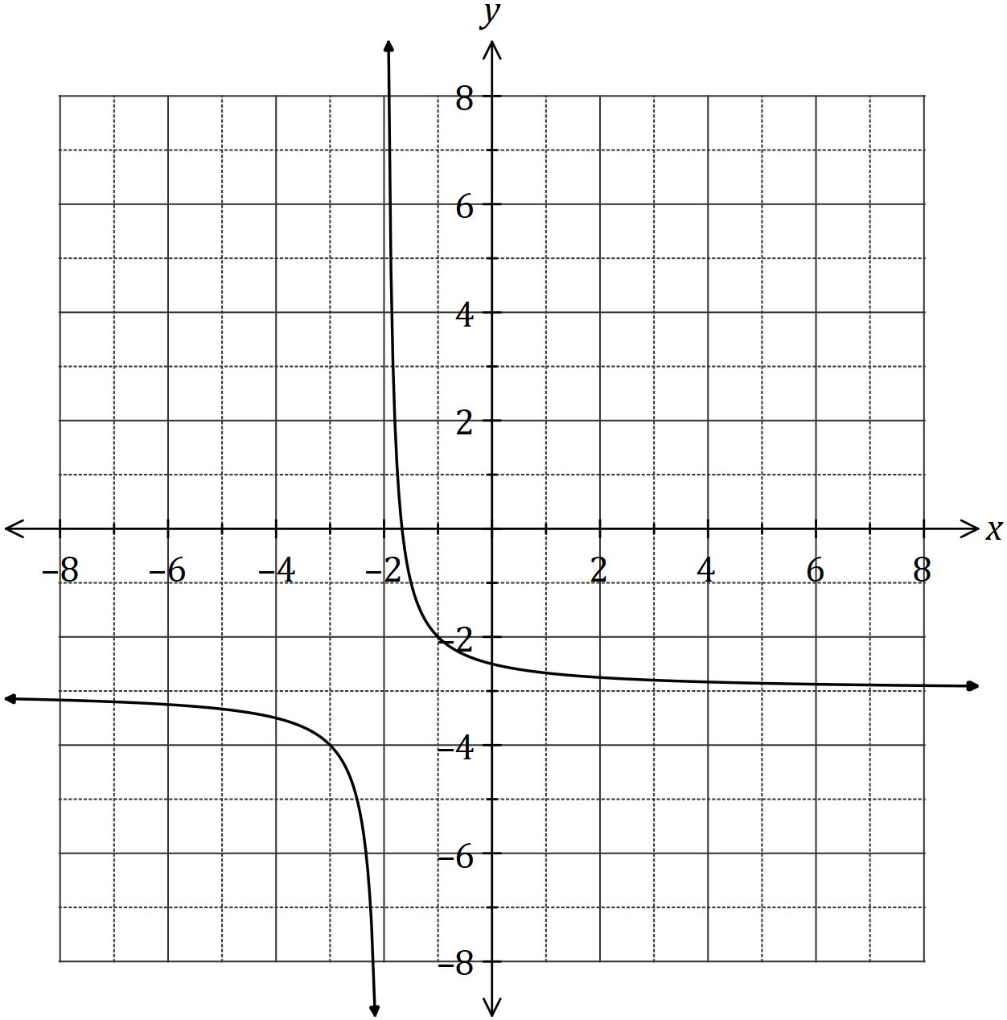

(a) Sketch the graph of $y=f(x)$ on the axes above, labelling all key features. (3 marks)

(b) Determine the values of $p$ and $q$. (2 marks)

(c) Solve the equation $f\left(x\right)=g(x)$, giving your solution(s) to two decimal places. (3 marks)

Question 14 (12 marks)

A logo with triangular outline $ABC$ contains a shaded segment bounded by the straight line $PM$ and the circular arc $PM$ with centre $B$ and radius $BM=18$ cm, as shown below.

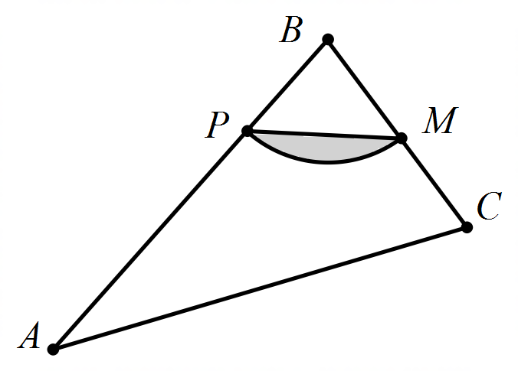

Given that $∠ABC=\begin{matrix}5π \\ \overline{12}\end{matrix}$, $∠BCA=2∠BAC$ and $M$ is the midpoint of $BC$, determine

(a) the size of $∠ABC$ in degrees. (1 mark)

(b) the area of the shaded segment. (2 marks)

(c) the perimeter of the shaded segment. (4 marks)

(d) the area of triangle $ABC$. (5 marks)

Question 15 (5 marks)

(a) Determine the equation of the axis of symmetry for the graph of $y=3x^{2}+12x+40$.

(2 marks)

(b) The graph of $y=ax^{2}+bx+13$ passes through the points $(-3,-23)$ and $(4, 5)$. Determine the values of the constants $a$ and $b$. (3 marks)

Supplementary page

Question number: _________

Supplementary page

Question number: _________

Supplementary page

Question number: _________

Supplementary page

Question number: _________

Supplementary page

Question number: _________